**Web Design: Project 3 documentation**

Table of Contents

**Design and inspiration1**

**Client Scope, User Considerations and Requirements:4**

**Requirements5**

**Flowchart6**

**Iterations7**

**References10**

**Design and inspiration:**

Out of HTML5up! Bootstrap and WordPress, we chose HTML5up as we were more comfortable using HTML and CSS than bootstrap’s class system and found WordPress to be too restricting.

Once we had chosen this, we browsed a series of different HTML5up! Templates to find what we liked or disliked in a template website. We chose the template first and wireframing later so that we could visually plan out our ideas and get an idea for how we wanted things to be located. The wireframe is more a means of drawing out the necessities to be built on and rearranged.

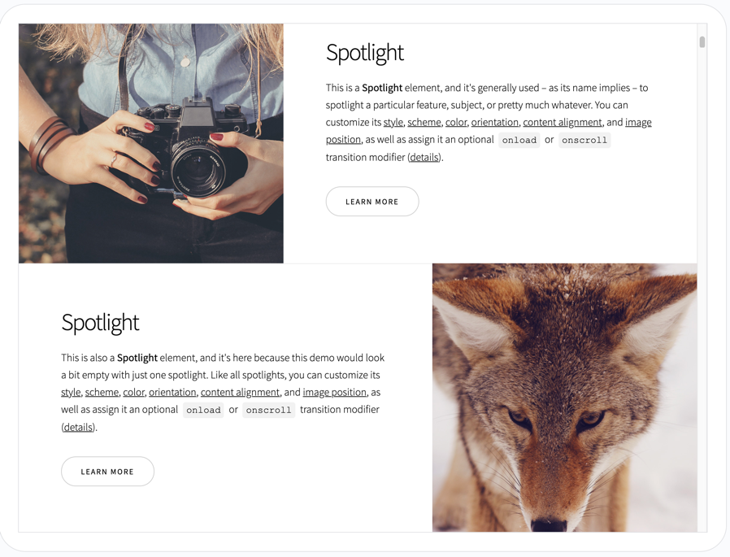

Spotlight was almost as appealing as Massively, but we disliked the bloggier style and how spaced out the information was.

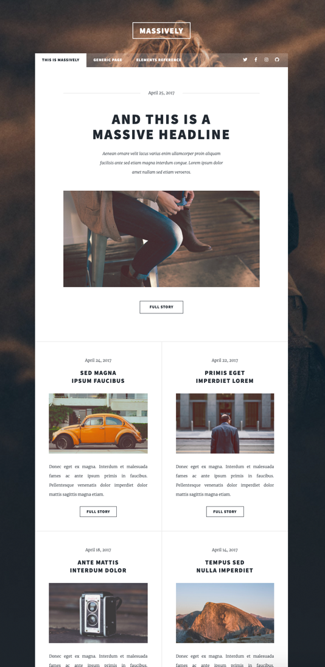

Massively is the first template we looked at and would ultimately be the one we chose. We really liked how clean and concise the homepage looked with its tiled layout.

What’s more, the template already fit a requirement for having multiple means of navigation.

Just looking at the site, we were able to mentally place the different required categories for two separate tours, rentals and a potential fourth category should we finish the other two.

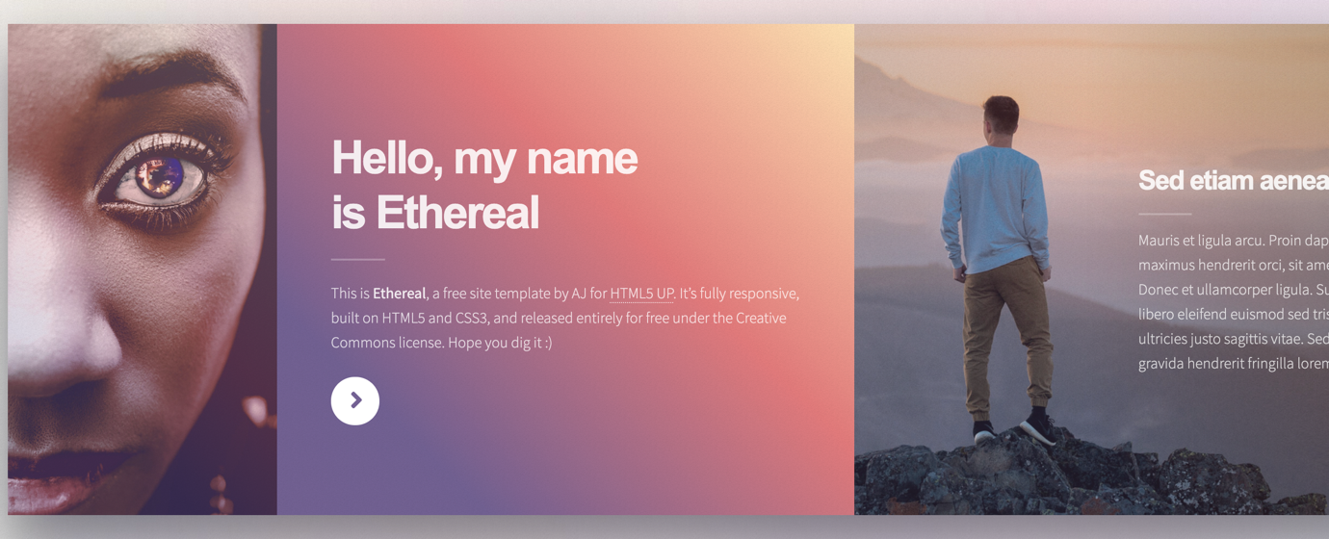

Ethereal and Dimension were both single page websites. Ethereal felt too linear to use. The need to scroll through the entire website to find what you wanted was not user friendly.

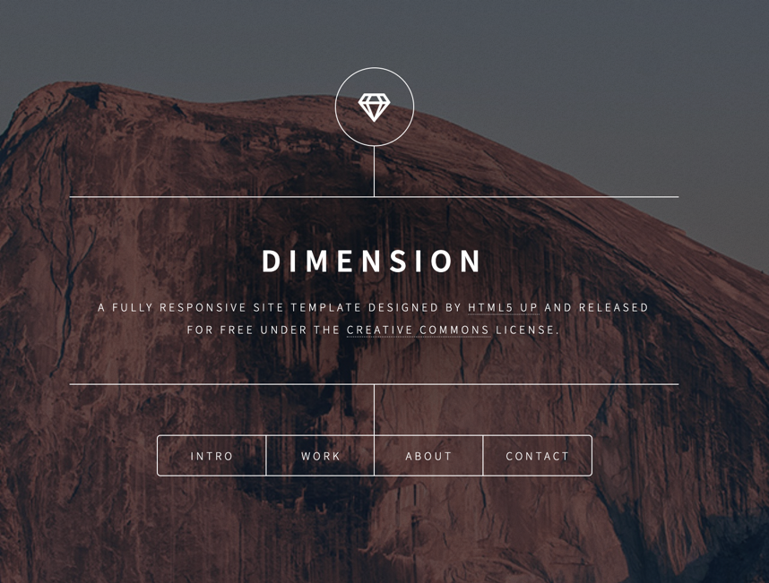

Dimension looked very aesthetically pleasing, but was more befitting of a portfolio, rather than an informative business website.

Thus, we decided on Massively as the base for our website – replacing the logo and title with “Explorers Southwest.”

With the method and template decided on, we set up a joint GitHub project as a means of version control. Further, I created three different branches on top of the main master branch so that each group member could work on their own list of requirements without potentially adversely affecting the others. Then once everything had been completed, I would merge them all back into one.

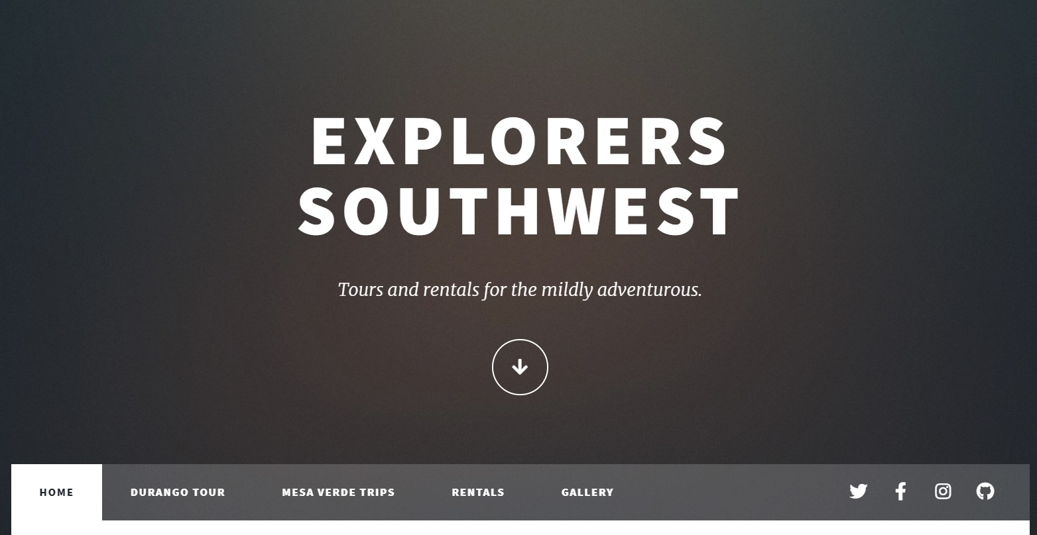

**Client Scope, User Considerations and Requirements:**

* User needs + requirements
* Client needs + requirements
* How does that fit the structure?
* Which LATCH to use? (Location, Alphabet, Time, Category, Hierarchy)

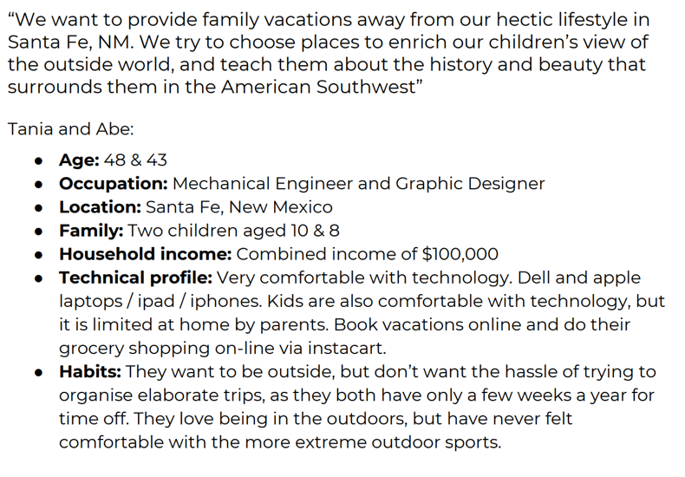

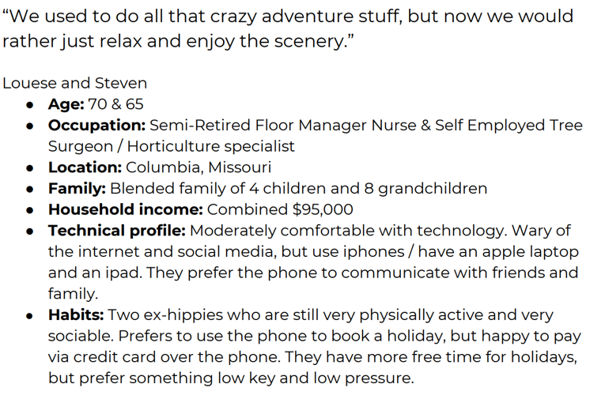

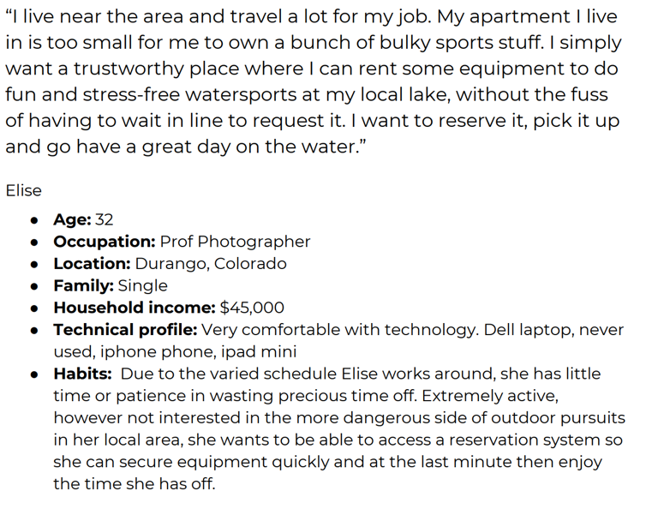

**Requirements:**

For navigation, we will use a mixture of hierarchy and alphabet.

Home will come first, followed by Durango Tour, Mesa Verde Trips and Rentals.

These four are the most important must have pieces of content.

Following these four will be Gallery. This is not required but will help attract photographer clients, or simply provide an additional incentive to visit the locations.

User needs:

* Information and eye-catching images regarding the different tours and rentals. Information and images should provide a feeling of adventure, exploration and the outdoors.
* Rentals should allow for booking at specific times. Not just form based, rentals need to have phone contact for on the fly renting.
* Contact information.
* Location.
* Easy to use layout and obvious navigation.

Client needs:

* All of the user needs plus a payment method.

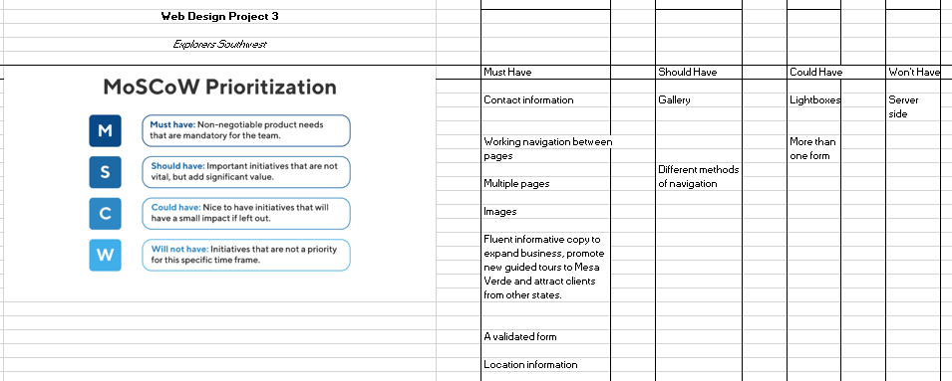

**Flowchart and wireframes:**

Home page



Durango Tour

Mesa Verde Trips

Rentals

Gallery



All pages are accessible from the other pages. Gallery will use the tile system. Tours and rentals will use the same text – image – text – form layout. All share form + contact footer.

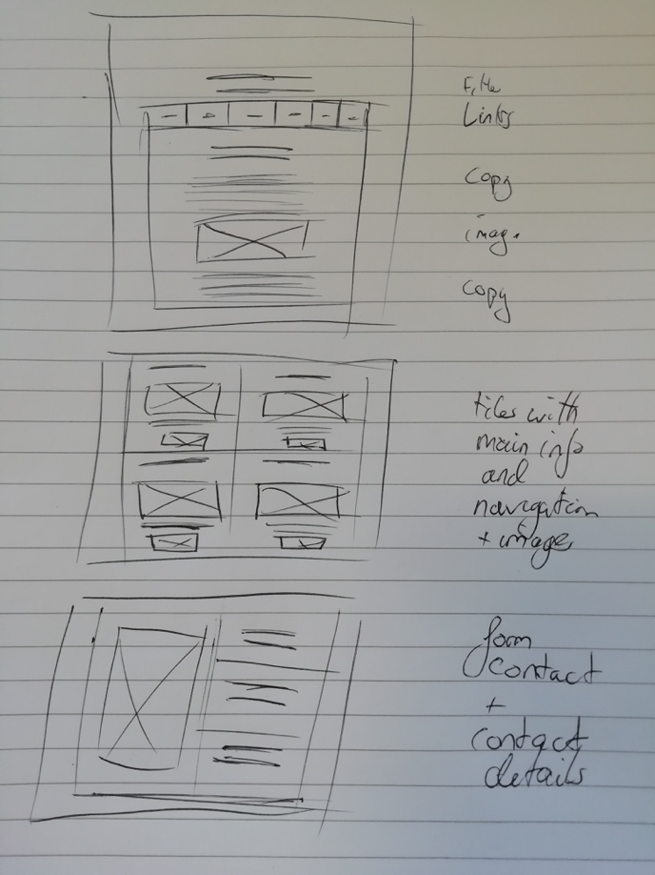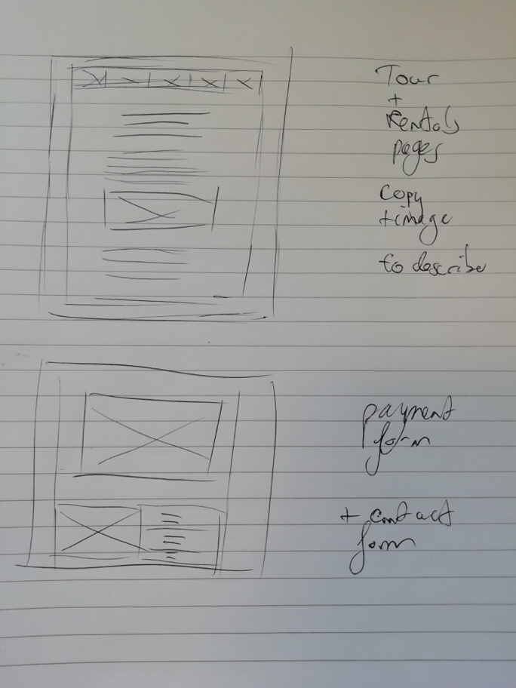

**Iterations:**

Following the decision of navigation, we realised that location information was missing. As such, we added in an extra Locations page:

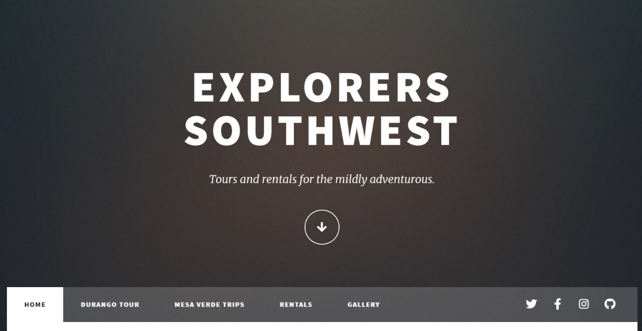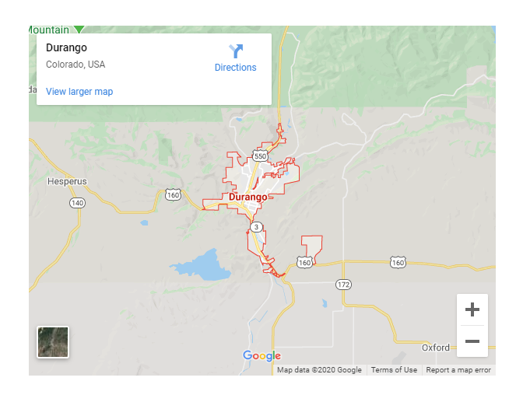

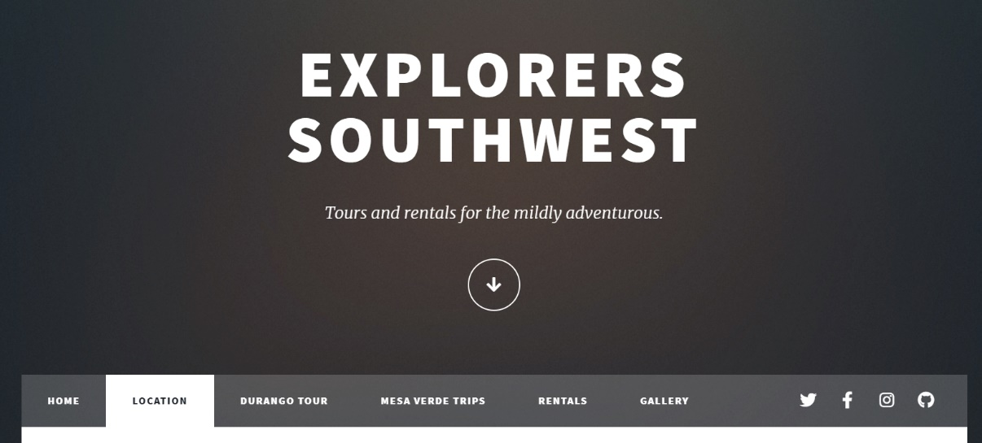

Inside the location page, we attached a Google Maps embed for Durango and some copy promoting the idea of travelling from different states or countries due to the nearby airport.

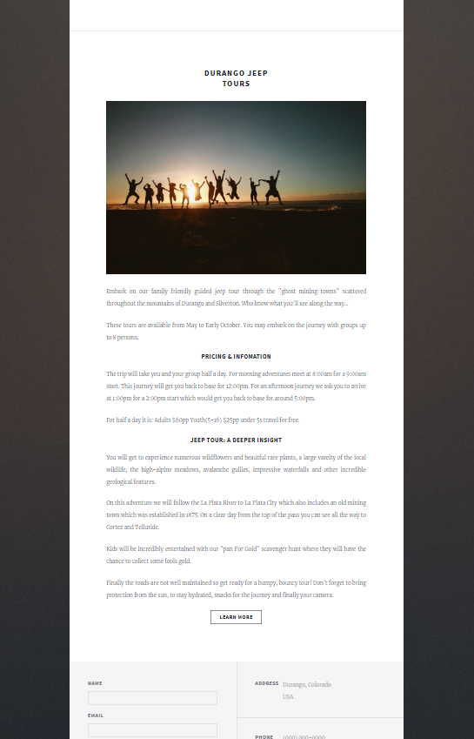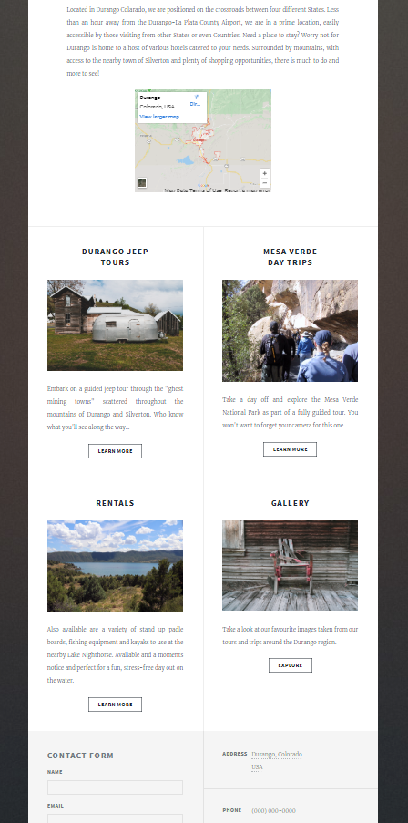We also experimented with and without including a secondary mode of navigation below the page content. The benefits of including it are that it offers an additional means of drawing attention from potential customers to different pages throughout the site. It presents a broader range of activities and could potentially be changed in the future to highlight different tours.

Further, we added a working link to the Address section of the footer which on click, takes you to the location page.

We also removed the scrolling header/ logo for everything but the Home page. This results in faster loading and reinforces the difference between the home page and information pages.

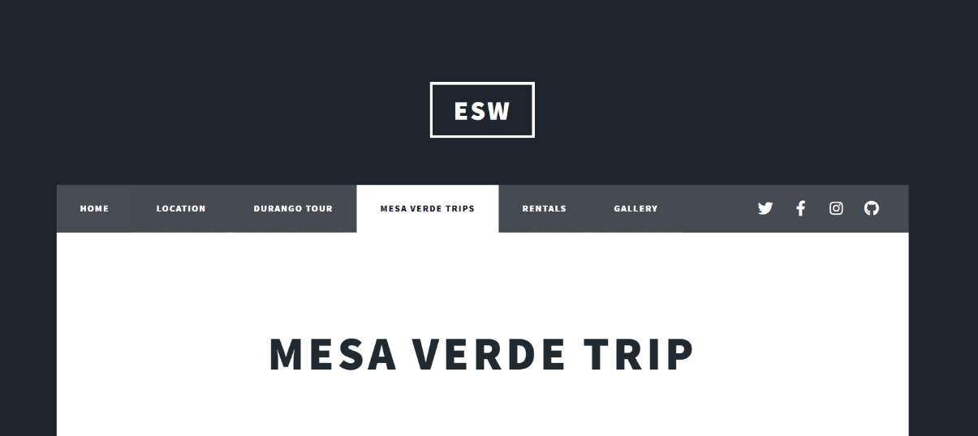

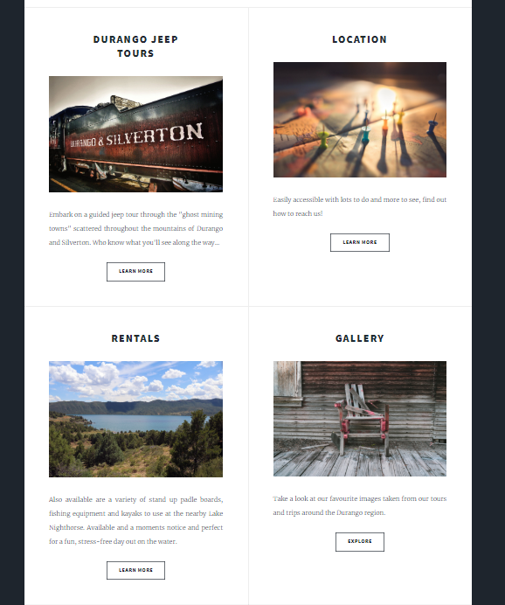Lastly, we changed the four tiles at the bottom so that the current page isn’t available to open.

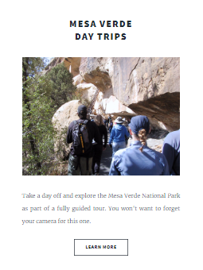For example, from the Mesa Verd Trip page, you can see the Durango, Location, Rentals and Gallery pages but not the Mesa Verde tile that would be visible from the other pages.

**References:**

HTML5 UP template:

Massively by HTML5 UP

html5up.net | @ajlkn | AJ aj@lkn.io

Free for personal and commercial use under the CCA 3.0 license (html5up.net/license)

Credits:

Demo Images:

Unsplash (unsplash.com)

Icons:

Font Awesome (fontawesome.io)

Other:

jQuery (jquery.com)

Scrollex (github.com/ajlkn/jquery.scrollex)

Responsive Tools (github.com/ajlkn/responsive-tools)

Image references:

FLICKR:

<https://flickr.com>

<https://www.flickr.com/search/?q=mesa%20verde>

Pexels:

<http://pexels.com/>

<https://images.pexels.com/photos/674782/pexels-photo-674782.jpeg?auto=compress&cs=tinysrgb&dpr=3&h=750&w=1260>

<https://images.pexels.com/photos/3796633/pexels-photo-3796633.jpeg?auto=compress&cs=tinysrgb&dpr=3&h=750&w=1260>

<https://www.pexels.com/photo/silhouette-photography-of-group-of-people-jumping-during-golden-time-1000445/>

<https://www.pexels.com/photo/person-taking-photo-in-sunset-756774/>

<https://www.pexels.com/photo/landscape-mountains-sunset-person-69100/>

<https://www.pexels.com/photo/body-of-water-2480667/>

<https://www.pexels.com/photo/landscape-photography-of-mountains-1557526/>

<https://www.pexels.com/photo/green-trees-on-hills-during-daytime-144172/>

<https://www.pexels.com/photo/landscape-photography-of-mountain-near-body-of-water-3390971/>

<https://www.pexels.com/photo/green-trees-beside-lake-under-blue-sky-3968052/>

Rawpixel:

<https://www.rawpixel.com/>

<https://www.rawpixel.com/image/2212385/bodie-ghost>

Unsplash:

<https://unsplash.com/>

<https://images.unsplash.com/photo-1559369657-236d20df1fa1?ixlib=rb-1.2.1&ixid=eyJhcHBfaWQiOjEyMDd9&auto=format&fit=crop&w=1350&q=80>

<https://images.unsplash.com/photo-1559116620-4e34d1ca535d?ixlib=rb-1.2.1&ixid=eyJhcHBfaWQiOjEyMDd9&auto=format&fit=crop&w=1950&q=80>

<https://images.unsplash.com/photo-1558934139-3df83040ed77?ixlib=rb-1.2.1&ixid=eyJhcHBfaWQiOjEyMDd9&auto=format&fit=crop&w=1951&q=80>

<https://images.unsplash.com/photo-1452828380758-183ec24b2ada?ixlib=rb-1.2.1&ixid=eyJhcHBfaWQiOjEyMDd9&auto=format&fit=crop&w=1950&q=80>

<https://images.unsplash.com/photo-1559116674-71fae8b32c95?ixlib=rb-1.2.1&ixid=eyJhcHBfaWQiOjEyMDd9&auto=format&fit=crop&w=1963&q=80>

Wikimedia:

<https://wikimedia.org/>

<https://upload.wikimedia.org/wikipedia/commons/0/0d/Lake_Nighthorse.JPG>